How COVID affected Water Consumption in Residential Buildings
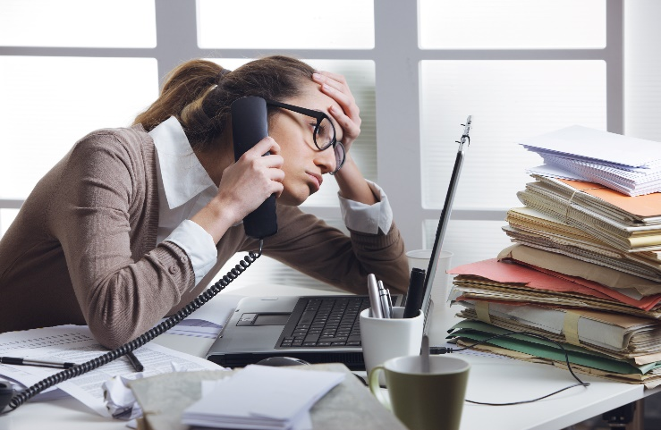

For the past year and a half, COVID affected every aspect of building management in New York, including water monitoring. Property managers expected residential water consumption to rise in properties where tenants were forced to spend more time at home; and consumption did rise by 10-20% in middle income residential properties. Conversely, consumption dropped in many high-end buildings where tenants escaped to second homes.
Managers were shocked when COVID-19 affected retail water consumption. Everyone assumed with stores closed, consumption would plummet. Ownership slowly realized that retail rents would not be forthcoming, and cancelled services requiring access to shuttered space (including meter reading). Rising DEP water bills were the first indicator that something was wrong, but management assumed that they were the result of increased residential consumption. If a Property Manager called the Department of Environmental Protection (DEP) to discuss the rising bills they were informed that due to COVID, DEP Inspections were cancelled, and would be resolved once the threat of COVID was over. Unfortunately, significant increases in consumption were detected when the stores re-opened and retail sub-meters were read. Management now had the unenviable task of collecting water bills from retail tenants who were refusing to pay base rent. When the tenant moved out the owner was stuck with the bill.
What was going on? How could empty restaurants, hair salons, and offices consume more water than when they were open? I have inspected hundreds of retail establishments since COVID began, and found that during the early stages of Covid-19, panic-stricken employees shuttered the gates, and ran home to quarantine, expecting to return in two weeks as the Mayor Predicted. Staff closed the stores, but they never properly shut down the space.
Water consuming mechanical equipment, swimming pools, cooling towers, reverse osmosis water filters, humidifiers, ornamental fountains, and trap primers continued to operate. Equipment sprung leaks that were undetected, faucets leaked, toilet flappers deteriorated, and no one was around to schedule repairs. Maintenance calls in shuttered space were cancelled, and repairs of small leaks were procrastinated as well.
In some cases, work tickets written prior to COVID were ignored for over a year. In extreme cases, faucets and flushometers had been left running as staff evacuated. As the saying goes, “No one was watching the shop”. Eventually staff returned, and the leaks were fixed. Responsibility for the bills became an issue of contention between the property owners and tenants.
The good news is that buildings with Automatic Meter Reading (AMR), averted this problem. The meters continued to be read hourly in shuttered spaces. Data continued to be transmitted and analyzed. Accurate tenant water bills continued to be generated. With hourly monitoring and mechanical equipment shut down, property owners saved electricity as well as water. Property owners did not have to deal with large bills or mechanical surprises, and averted water damage due to endless leaks.
The past year taught us that buildings live and breathe. They cannot be ignored just because we are not using them. Mechanical and Electrical systems must be monitored continuously. Typically, we take this monitoring for granted. Staff walk the buildings every day & tenants notify us of their problems. As a result, this forces us to maintain the property. Rarely is a problem allowed to fester. In the rare event that a building is being shut down, an Engineering Firm is hired to decommission the building. We now know that we have to install monitoring systems that will operate without human interaction.
Water Meter monitoring systems such as Accuwater are simple to install, and are cost-effective. Sub-meters are installed in locations prone to leaks like cooling towers, boilers, water cooled equipment, hair salons, restaurants, etc. Each meter is paired with a data logger, and transmitter. This data is transmitted to the cloud where it is recorded and analyzed. Finally, Water Bills and Leak Notifications are sent to management on a regular basis. The data can also be used to track return on investment (ROI) of conservation projects.
The following steps should be undertaken by all properties planning on sub-metering their retail space:

- Review your retail leases. Make sure you are billing for actual water use based on meter reading.
- Only provide retail tenants with cold water. Have them create their own hot water. The BTU’s used to create hot water cost more than the water, and are always a contentious issue.
- Make sure that a sub-meter is installed in each retail space, and the tenant is responsible for the cost of maintenance.
- Make sure the tenant is responsible for all associated fees, including the installation of the meter, meter reading device, and service.
- Install meter reading device on meter, and engage service to read the meter.
- Provide a portal that allows a manager, tenant, and super to monitor consumption.
- Bill tenant for consumption monthly. Don’t let surges in consumption drag on.

The average system should find many leaks, remove headaches, and pay for itself within 6 months. More information about Accuwater can be found at www.ashokansaves.com. Contact Emilie Rudy at +1-(718)-499-4008.

If you prefer communicating via email, feel free to send us a message at info@ashokansaves.com.

Author: Hershel Weiss

Biography:
Hershel is both a mechanical engineer and NYC master licensed plumber. Public Service includes President of American Society of Plumbing Engineers (ASPE), NYC Sustainability Advisory Board, DOB Master Plumbers Board, NYC DOB Innovation Board, Mayor’s Green Codes Task Force and currently serves on the Existing Plumbing Code Adoption Committee. Hershel is an avid kayaker, his personal goal is to minimize the effects of CSO and storm water runoff within the Hudson River Estuary in order to create a positive impact on New York City’s environment.


